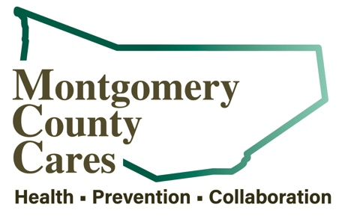
Montgomery County Cares
Meeting Minutes
Mar 8, 2022, Zoom

Attendance: Gwen Ossenkop, Cassandra VanNostrand, Rachel Marcey, Father Neal Longe, Clayton VanValkenburgh, Bonnie Peck, Ginger Champain, Aaron Quigley, Allison Craig, Luke Prime, Laurie Bargstedt, Patrick Crouse, Alexis Dutcher, Julie Adamec, Maura Fiddle, Alexis Dutcher, Clayton VanValkenburgh, Sally Baker

TOPIC | DISCUSSION | OUTCOME/FUTURE ACTIONS
Welcome/Introductions | Welcome P Tech students Alexis and Clayton!!! We’re so happy to have you join us!
Approval of February 9 2022 minutes | 1-Ginger Champain 2- Luke Prime / Approved
Spotlight Speaker:  Ginger Champain, Cancer Prevention in Action | Ginger Champain, Cancer Prevention in Action of Fulton, Montgomery, Schenectady counties are covered. March is National Colorectal Cancer Awareness Month. In cancers that affect both men and women, colorectal cancer is the second leading cancer that people are most likely to pass away from. But most cases are preventable. Through routine screening tests. A video from the CDC was aired about colon cancer screenings. There is a free collaborative Cancer Prevention First Responders Workshop April 9th at Montgomery County Emergency Management Office on Rt. 5S 8:30 to noon. Breakfast will be provided and seats still available. Please RSVP to Kelsey.carpe@nysmha.org
Sticker Shock Campaign  Youth/Parent Coordinator  Beyound the Branding  Julie Ademec, Healthy Alliance | Labels/stickers will be placed directly on alcohol bottles/cans to remind clerks that they need to ID. Three designs, 100 of each. Send design ideas to Gwen for FMCC students to design for Sticker Mule to produce. On Mondays Sticker Mule offers deals. Give the designing student(s) a few to use in their portfolio.  Kathie LaBarge has been hired and will work 10hrs/wk to help recruit parents and students, focusing on the Western part of the county.  One Pill can Kill will be on billboards, radio ads and also used on social media campaigns  Spoke about the “Unite Us” referral network intended to focus on Whole Person Care-the right care at the right time in the right setting. Referrals are made through a Coordination Center or from business to business, CBO. Consent must be gained from the person. Contact Julie for more information.
New Business:  OD Mapping / Narcan  Budget  Training  Note takers and Spotlight Speakers  New Co-Chairs  Bike Ride | Numbers were reviewed and are included in the minutes.  Expenses were reviewed for CADCA, the NY Problem Gambling Virtual Conference, and Spotify Ads.  The Opioid Response Network and CADCA Training will take place in April. The data used for this training is specific to Montgomery County.  CADCA Summit- May 11th from 9:00am – 3:00pm, lunch on your own. Training at Allen House, FMCC.  Looking for notetakers for July, Sept, Nov and SS for June and July. Laurie Bargstedt will take Aug and Maura Fiddle will take Nov.  Cassandra VanNostrand is the Chair and Rachel Marcey is the new Co Chair  MHA and NEU will collaborate to put on a Bike Ride Event with tabling! May 21 in Vales Mills and June 4 at Canajoharie- days and times may change

Member Reports: Ginger –The new Recovery Center in Amsterdam will open in March. There will be a sober Super Bowl party at 6pm on Sunday at the Recovery Center in Gloversville.
Cassandra, PPGNY, is available in person or virtually for education, also for tabling. Laurie-Literacy Zone has a new ELL project starting in July, offers HS equivalency diploma Patrick is in year 6 of the DFC grant.
Next Zoom meeting: Tue April 12, 2022 @ 1pm
Next Month’s Spotlight Speaker: CADCA OPIOID TRAINING
Next Month’s Note Taker: NONE- PRESENTATION WILL BE RECORDED
