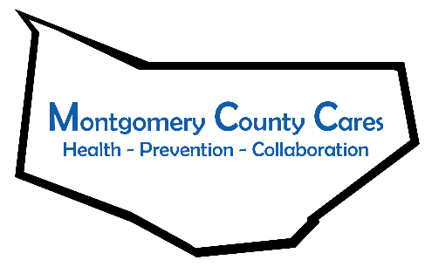
Montgomery County Cares
Meeting Minutes
Jun 14, 2022, Zoom

Attendance: Gwen Ossenkop, Bonnie Peck, Ginger Cato, Aaron Quigley, Allison Craig, Luke Prime, Kelsey Carpe, Elizabeth Aurmand, Sharlee Berenger, Sally Baker

TOPIC | DISCUSSION | OUTCOME/FUTURE ACTIONS
Welcome/Introductions | Welcome!
Approval of February 9 2022 minutes | 1-Ginger Cato 2- Kelsey Carpe / Approved
Spotlight Speaker:  Aaron Quigley, Spectrum Reach | Aaron works for Spectrum Reach in the Advertising department. The #1 Network is Spectrum News, located in the Schenectady zone which includes 50 zip codes, paid social programming, 100+ network lineups.  Aaron will send Gwen a questionnaire for a free commercial.
Sticker Shock Campaign  Youth/Parent Coordinator  Beyound the Branding | Labels/stickers will be placed directly on alcohol bottles/cans to remind clerks that they need to ID. Three designs, 100 of each. Send design ideas to Gwen for FMCC students to design for Sticker Mule to produce. On Mondays Sticker Mule offers deals. Give the designing student(s) a few to use in their portfolio.  Cathy LaBarge has been hired and will work 10hrs/wk to help recruit parents and students, focusing on the Western part of the county.  One Pill can Kill will be on billboards, radio ads and also used on social media campaigns
New Business:  OD Mapping / Narcan  Budget  Training  Behavioral Survey  Narcan Boxes  Mohawks Games  Prom Promise | Numbers were reviewed and are included in the minutes.  No new expenses  Will occur in 2 schools in November, more info to follow  There are 13 boxes that will be put up, 4 at FMCC.  Tabling is available for 1 or 2 or 3 games. Contact Gwen if interested.  60 students signed the Prom Promise and a huge sign was signed, high interest level by youth!

Member Reports: Ginger –The new Recovery Center in Amsterdam will have the Grand Opening June 28, 2022 at 1pm.
Bonnie – Glove City Pride Picnic, June 29, contact Bonnie if you’d like to table.
Elizabeth – July 24-end of August there will be sacks of food for pick-up in Canajoharie.

Next Zoom meeting: Tue July 12, 2022 @ 1pm
Next Month’s Spotlight Speaker: ________________________________
Next Month’s Note Taker: ________________________________________
