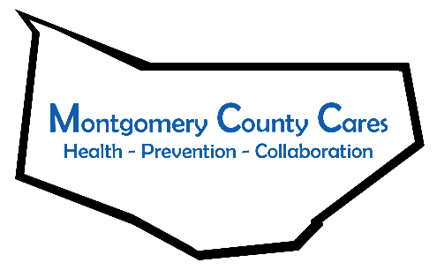
Montgomery County Cares
Meeting Minutes
Date of meeting:

Attendance: Gwen Ossenkop, MCC Coordinator; Ginger Cato, Recovery Center; Kim Shainberg, Safe Harbour; Sally Baker, CDTF; Sharleen Berenger, Nydia Hill, New Choices; Ariana Mattice-Lybrand, District Office Manager of Assemblyman Santabarbara; Alyssa Craig, Creative Connections Clubhouse; Kelsey Carpe, Cancer Prevention in Action; Nancy Deumaga, Mental Health Association; Lisa Cimo, Tina Morey, Sexual Assault Support Services; Kelley Gilligan, Catholic Charities Domestic Violence and Crime Victim Services; Laurie Bargstedt, HFM BOCES Adult Literacy; Michele Ciani, Catholic Charities; Kathy Stangle, Headstart; Elizabeth Aurand, St. John’s & St. Mark’s, Canajoharie; Vanessa Carey, Catholic Charities Emergency Assistance;

TOPIC | DISCUSSION | OUTCOME/FUTURE ACTIONS
Welcome/Introductions
Approval of minutes
Spotlight Speaker | Laurie Bargstedt—HFM BOCES, Adult Literacy and Corrections Literacy Zones  -Adult Basic Education  -HEE College & Apprenticeship Training  -ESLAvailable in Amsterdam  -IC3 digital literacy will phase out after 1 more year  -Still distance learning; if no access to technology, participants can receive paper packets with all information and work  - Amsterdam and Gloversville Literacy Zones are on Facebook! Will post or share updates from other organizations  -Openings for part-time teacher aides; senior accounting clerk  -Continuing to take students 18 years and up  -Continuing to partner with Workforce Solutions
Old Business
Capacity Survey | -Gwen sent the results of the capacity survey in a powerpoint for the coalition  -pointed out certain statistics, such as members feel only 45% of the community is aware of the coalition and their efforts  -need for more youth engagement | -with these results, the Capacity Building action team will begin working  -Coalition trainings will be available for members
New Business
Call for Action Team Members | -A need for coalition members to join action teams covering: community outreach, capacity building and trainings. | -Action teams will begin meeting to set goals for their teams  -If interested in joining any of the action teams, reach out to Gwen
New Logo Survey Results | -New logo has been chosen!  -Some changes for logo has been requested by members of the coalition | -Will send the changes to the class and will report back to the coalition with the updated logo
Coordinator updates | -Early May will be Week 2 of CADCA  -Partnering with Creative Connections for chalk the walk  -Parent and Student surveys for focus groups will begin soon

Member Reports
Kelsey (Cancer Prevention in Action): Actively achieving new policies in Fulton County; will be present at Fishing Derby and proving sun safety education; website is: takeactionagainstcancer.com
Brandy (NY Problem Gambling): Thank you to everyone who participated in Problem Gambling Month; will be sending out a community stakeholder survey; Save the date for October 27 & 28 for National Conference.
Rachel (PPGNY): Pride is in June; many upcoming activities, both virtual and in person events; PPGNY’s LGBT Navigator is providing assistance and trainings on a variety of topics; Pride, Pronoun, and Ally pins available. Contact Rachel at Rachel.marcey@ppgreaterny.org
Kathy (Headstart): Headstart is now 4 days a week in all locations; Materials are being sent to anyone off site; Positions are open for teacher, bus aide, kitchen aide, and recruiter; contact Amsterdam site for more information
Alyssa (Creative Connections): The Clubhouse received the Saratoga Arts Grant; purchased a vinyl machine to make clothing; there will be a mural painted for the basketball court, the mural will be a contest through Amsterdam HS.
Ginger: Moving Recovery Center from Johnstown 37 Bleeker St in Gloversville in May after some renovations; Grand opening will be in mid-June.
Cassandra (Planned Parenthood): Planned Parenthood in Amsterdam is open for in person and telehealth appointments; Cassandra is available for any outreach and education needs, contact at cassandra.vannostrand@ppgreaterny.org

Next Zoom meeting: Wednesday,May 12, 2021 @ 9:30 AM
Next Month’s Spotlight Speaker: Rachel Marcey; PPGNY
Note Taker:

